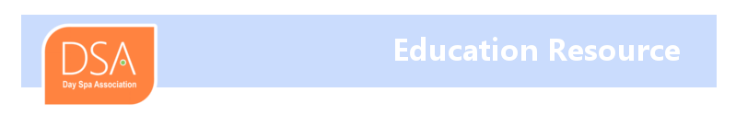

A guide to adding the beauty of safe, certified, tested gold to your spa program

Gold holds a special place in our hearts – its captivating, unchanging quality and luminous glow have been used to adorn the body for thousands of years, from before the reign of Cleopatra, and in cultures around the globe. GoldCosmetica is the product of nearly one hundred fifty years’ expertise in producing new cosmetic grade gold leaf for face and body skin wellness. Balancing the beauty of a natural element with state of the art gold beating techniques in Germany, GoldCosmetica provides the glamorous allure and benefits of pure gold with straightforward application. 24K Cosmetic Gold for Face and Body has been clinically tested by the Swiss Skin Institute, and demonstrates:
Anti-aging with reduction of wrinkles and improved skin elasticity
Rejuvenation and firming
Calming of inflammation and redness
Skin brightening and radiance
In terms of immediate effects, clients experience and see a subtle sparkle left from residual micro-particles post treatment. Moisture retention is increased, and skin smoothness is boosted. GoldCosmetica can be used with any and all of your current favorite products, so you can create custom treatments for your clients – GoldCosmetica is compatible with all skin types. As a pure material, 24K gold offers maximum impact, since it is not “watered down” like many other gold applications.
While your clients enjoy the mystique and romance of genuine gold, you can experience how easy it is to use – below you’ll find an overview of our specially designed spa products and their (simple!) application protocol, developed through testing and in the field with expert estheticians around the world. Each product is designed to help you quickly and easily integrate this luxurious element in your spa program as add-ons or special packages.

Application Tips
24K Gold for Face and Body
GoldCosmetica 24K Gold is packaged in booklets of twelve two-inch squares backed with soft, flexible paper backing. It is generally recommended to apply 24K towards the end of treatment, if not the final step. There are several advantages to this: it naturally soothes skin after cleaning, exfoliation and laser treatment, boosts moisture retention, and leaves a shimmer on the skin if not entirely washed away (more on this below).
Clean and prepare the skin as usual for the particular needs of your client. 24K is designed to use with all skin types and products, so you have complete discretion to perform cleaning, exfoliating, peels, light/LED treatments, etc.
24K gold is inherently “clingy”, and will adhere to any oily, creamy, humectant moisturizer including serums, hyaluronic acid, vitamin C and other products. Apply your choice and allow it to sit for a couple of minutes if necessary to achieve a dry tackiness. Gently pull a gold sheet from the booklet, holding only the paper. Flip the paper so the gold faces the skin, then press down and rub the paper so the gold releases from the backing onto face or body. You can repeat until all the gold is removed from the paper onto the skin. Twelve squares are provided per facial treatment, you may find you use fewer. After application, the gold can rest on the skin for 10-15 minutes. You may choose to massage it slightly, or just leave it. During this time you can steam – the gold is a lovely, semi-permeable veil that allows moisture to pass through. After this you can massage lightly with your hands or a moist cloth, depending on the solubility and stickiness of the underlying humectant. The gold will disperse over the skin, to the point that it nearly disappears. You can control the amount you leave on the skin – most clients love to see a subtle shimmer. Some spas apply a “kiss” of gold flakes to the still-moist skin to cap off the facial experience. It’s a lovely and beneficial way to add an extra treat to a luxury treatment.
A note about Pure Cosmetic Silver Leaf – silver is a wonderful anti-bacterial metal with soothing properties, and long revered in ancient eastern methodology. It can be used all-over or to spot-treat blemishes/problem areas.
24K Eye Pads
Eye pads’ crescent shape gently embraces the delicate under-eye area. They are handled in the same way as the 24K squares, ideally left on for 10-15 minutes. Use any eye area products you choose to help the gold adhere. Eye Pads also wash away with gentle massage and a bit of moisture as needed. They provide a beautiful pick-me-up for tired under-eye tissue, and minimize crow’s feet. You will find that like the 24K Gold squares, the Eye Pads enhance the performance of your other products.
Cosmetic Gold Flakes
Gold Flakes are simple to use and very versatile. They can be used as part of facial, body, hand or foot treatments, and to help create your own custom products for treatments or for retail. They also embellish cheeks, lips, brows and hair, provided that an initial balm or appropriate humectant is used first. The most efficient way to handle flakes is to use a small fan brush to “spoon” out a little at a time. Simply tap the flakes over cleaned, prepared skin as for 24K squares, repeating as necessary. Allow 10-15 minutes, performing steaming as desired during this time. Massage or wipe away as indicated for the 24K squares. A fan brush is also useful to dose your own custom products. If using as a special highlight for skin, first apply an appropriate lotion, crème, balm or similar in very small amounts – the sheerest amount is needed to allow the flakes to adhere the way you want them to. Tap the flakes and adjust by adding more, or reduce the amount by gently rubbing the flakes onto the skin – they naturally disintegrate into smaller particles. It is important to keep your Gold Flakes application brush dry and free of contaminants from any wet/oily products – keep the brush dedicated for gold use only, it’s your magic wand!
Gold Manicure/Pedicure
23K Nail Care gleams on fingers and toes because it is a solid sheet of metal, not particles dispersed in lacquer. You can apply the gold squares over just a basecoat, or over a couple of layers of colored nail lacquer. Simply allow the lacquer to dry for a couple of minutes, then press the gold onto the nail, rubbing firmly over the paper to release gold. You can continue rubbing until all the gold is released. Then apply your choice of topcoat. The gold should last as long as the manicure.
All GoldCosmetica products provide spas with a unique way to shine – combining the luxury and unparalleled beauty of natural gold with easy integration into your repertoire. Your clients will love the exquisite shimmering glow of skin, hair and nails pampered with GoldCosmetica gold treatments.
To find out more about GoldCosmetica’s skin benefits and how to add the romance of certified gold to your services, please contact Jennifer@goldcosmetica.com.

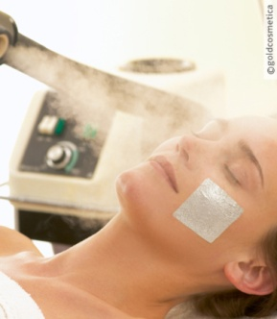
24K gold and in this case silver can rest on the face allowing steam to penetrate

After 10-15 minutes, massage in or wipe away with moist hands or cloth

24K radiates a luminous glow unlike any other skin treatment

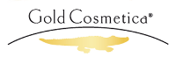

Jennifer Longworth
Sales Manager, North America

